SQL 50 Questions and answers
Q1. Display the first 10 records from the matches table.
SELECT *
FROM matches
LIMIT 10;
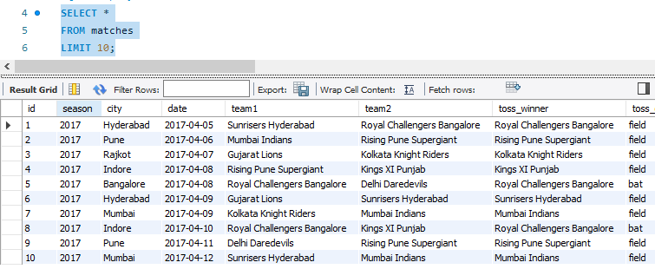

Q2. Display the first 10 records from the deliveries table.
SELECT *
FROM deliveries
LIMIT 10;

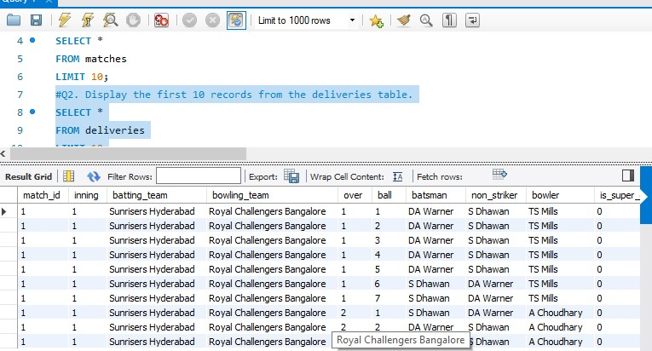

Q3. Count the total number of rows in the matches table.
SELECT COUNT(*) AS total_matches
FROM matches;
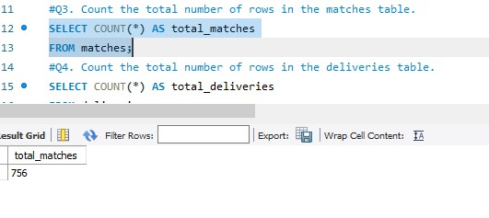

Q4. Count the total number of rows in the deliveries table.
SELECT COUNT(*) AS total_deliveries
FROM deliveries;

Q5. Display all unique IPL seasons from the matches table.
SELECT DISTINCT season
FROM matches
ORDER BY season;
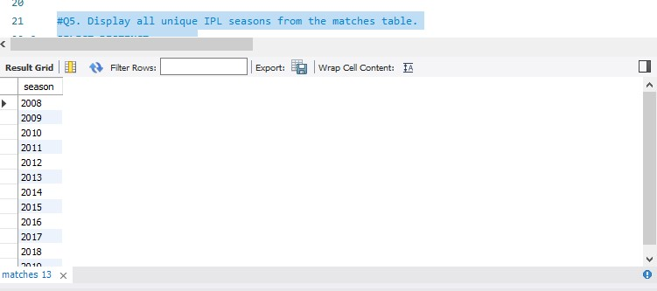

Q6. Display all unique cities where IPL matches were played
SELECT DISTINCT city
FROM matches
WHERE city IS NOT NULL
ORDER BY city;

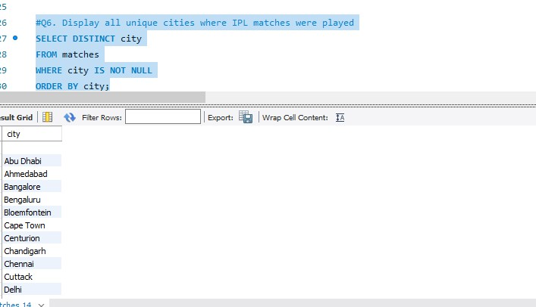

Q7. Display all unique team names appearing in the team1 column.
SELECT DISTINCT team1
FROM matches
ORDER BY team1;

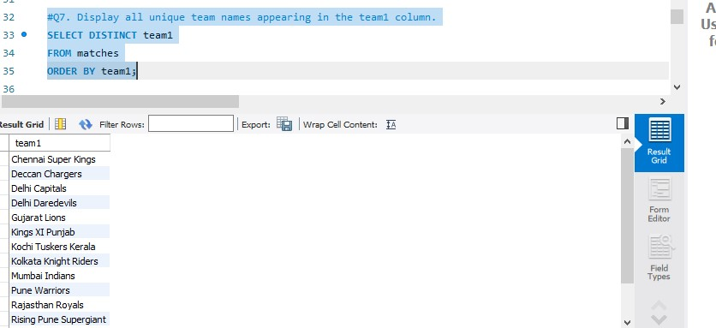

Q8. Display all matches played in the 2017 season.
SELECT *
FROM matches
WHERE season = 2017;
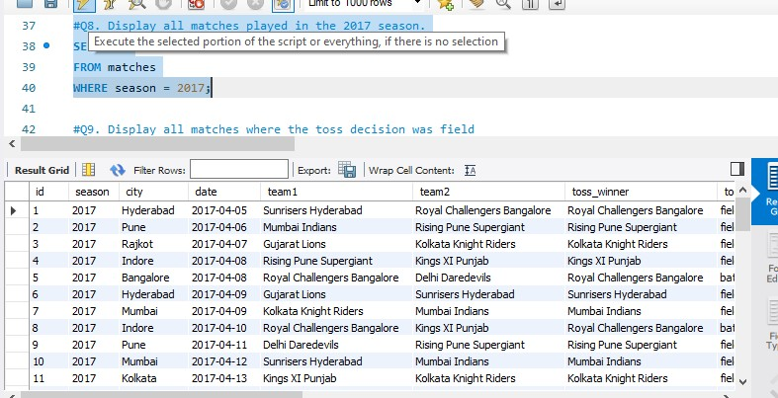

Q9. Display all matches where the toss decision was field
SELECT *
FROM matches
WHERE toss_decision = 'field';
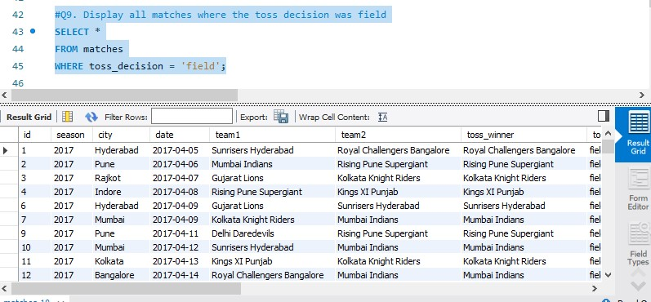

10 Display all matches won by Mumbai Indians
SELECT *
FROM matches
WHERE winner = 'Mumbai Indians';

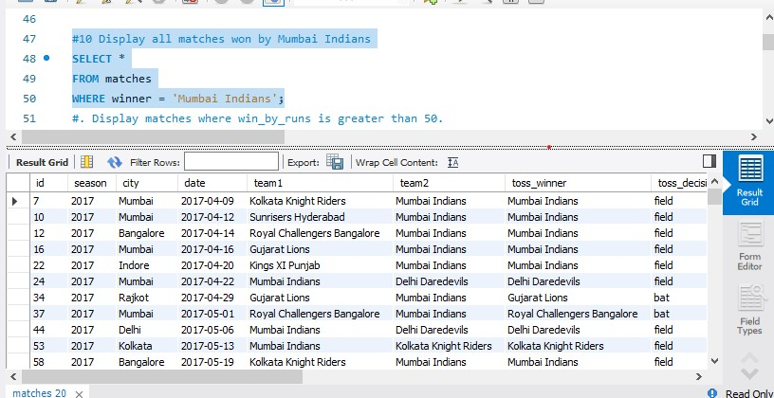

Q12. Display matches where win_by_wickets equals 10.
SELECT *
FROM matches
WHERE win_by_wickets = 10;

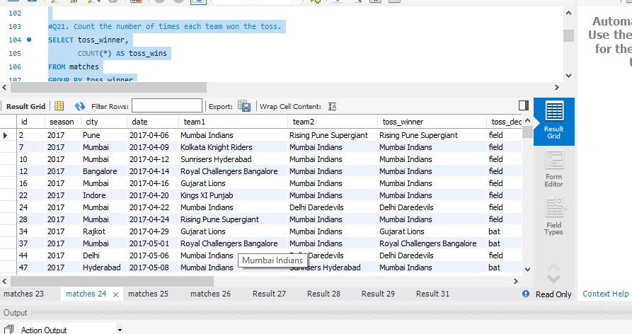

Q13. Display matches where the toss winner and match winner are the same team.
SELECT *
FROM matches
WHERE toss_winner = winner;

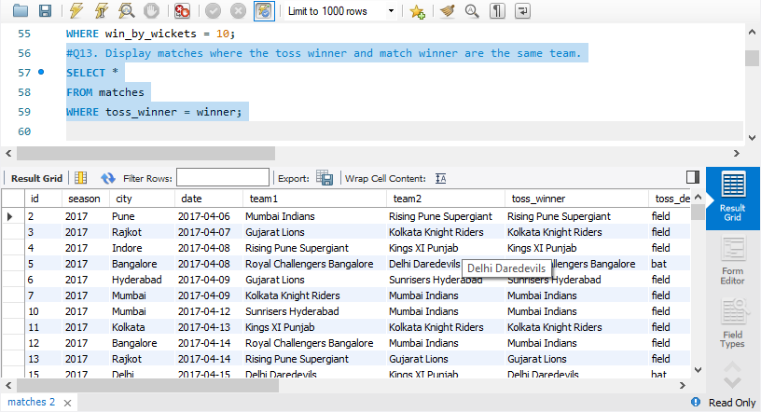

Q14. Display matches where Mumbai Indians appears as either team1 or team2.
SELECT *
FROM matches
WHERE team1 = 'Mumbai Indians'
OR team2 = 'Mumbai Indians';
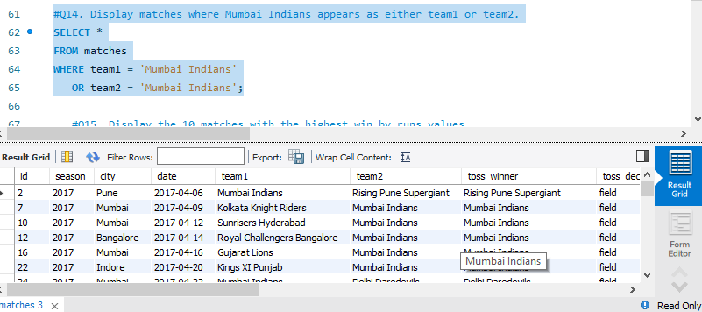

Q15. Display the 10 matches with the highest win_by_runs values.
SELECT *
FROM matches
ORDER BY win_by_runs DESC
LIMIT 10;

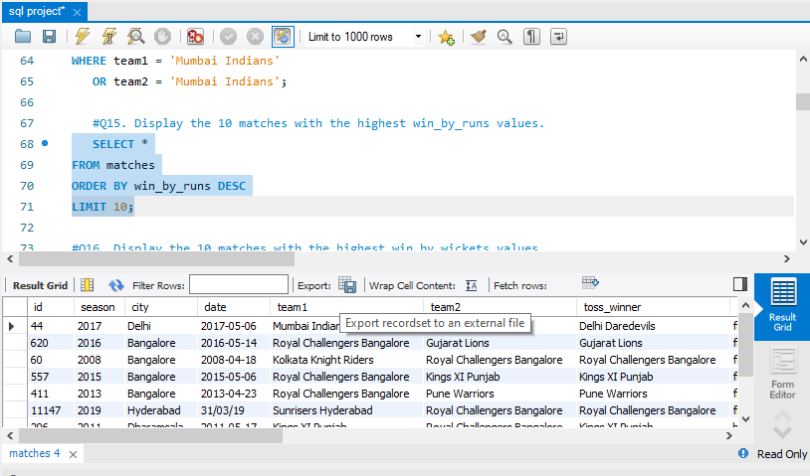

Q16. Display the 10 matches with the highest win_by_wickets values.
SELECT *
FROM matches
ORDER BY win_by_wickets DESC
LIMIT 10;

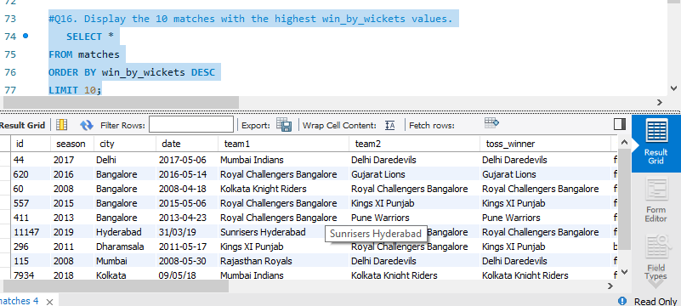

q17 Count the number of matches played in each season.
SELECT season,
COUNT(*) AS total_matches
FROM matches
GROUP BY season
ORDER BY season;
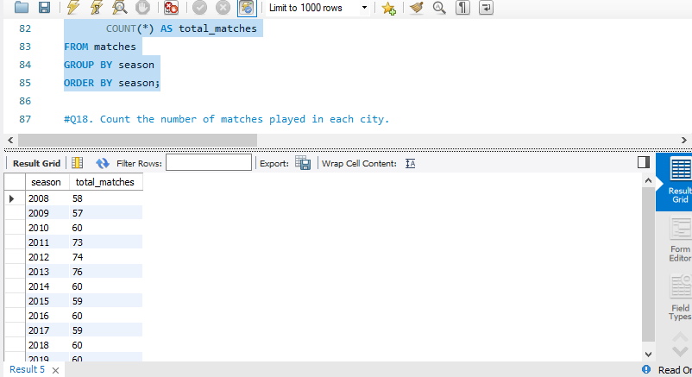

Q18. Count the number of matches played in each city.
SELECT city,
COUNT(*) AS total_matches
FROM matches
WHERE city IS NOT NULL
GROUP BY city
ORDER BY total_matches DESC;

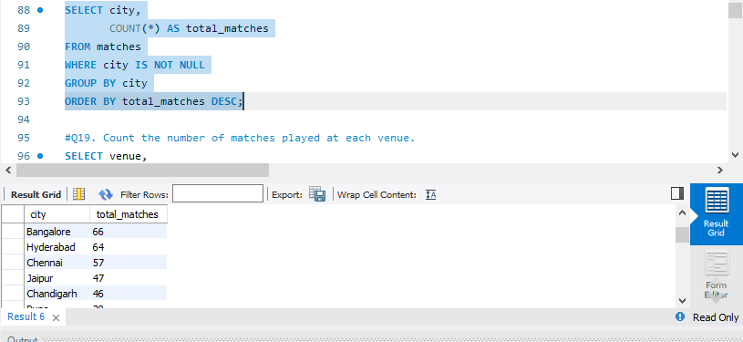

Q19. Count the number of matches played at each venue.
SELECT venue,
COUNT(*) AS total_matches
FROM matches
GROUP BY venue
ORDER BY total_matches DESC;

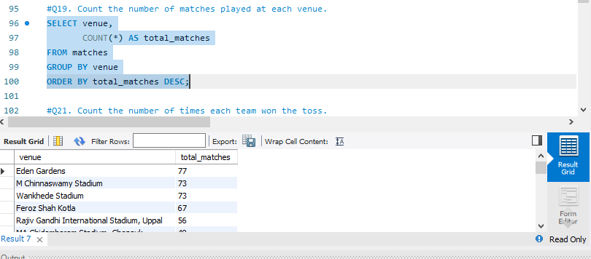

Q21. Count the number of times each team won the toss.
SELECT toss_winner,
COUNT(*) AS toss_wins
FROM matches
GROUP BY toss_winner
ORDER BY toss_wins DESC;

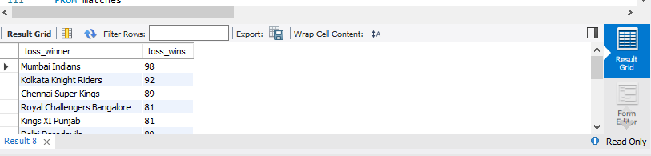
Q22. Count the number of bat and field toss decisions.
SELECT toss_decision,
COUNT(*) AS total_decisions
FROM matches
GROUP BY toss_decision;
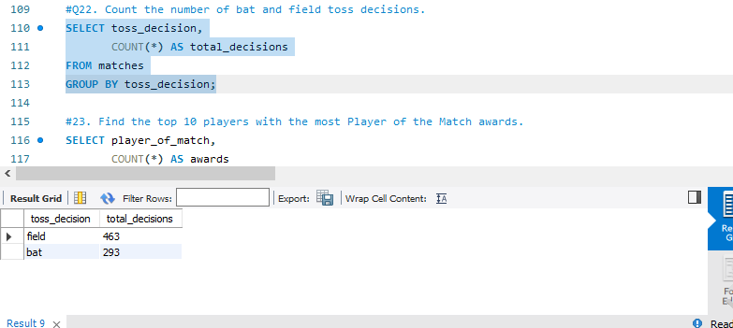

23. Find the top 10 players with the most Player of the Match awards.
SELECT player_of_match,
COUNT(*) AS awards
FROM matches
WHERE player_of_match IS NOT NULL
GROUP BY player_of_match
ORDER BY awards DESC
LIMIT 10;
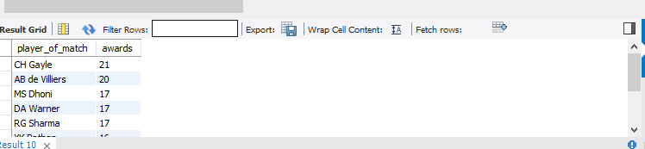

24Find the average win_by_runs for each season.
SELECT season,
AVG(win_by_runs) AS average_win_by_runs
FROM matches
GROUP BY season
ORDER BY season;
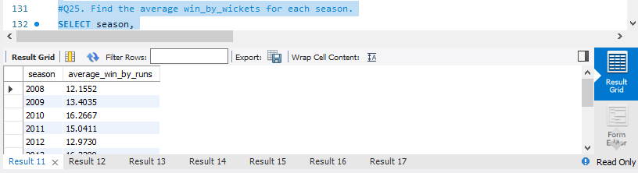

Q25. Find the average win_by_wickets for each season.
SELECT season,
AVG(win_by_wickets) AS average_win_by_wickets
FROM matches
GROUP BY season
ORDER BY season;
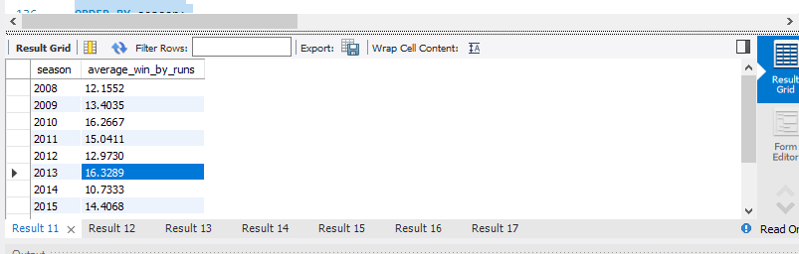

Q26. Find the maximum win_by_runs recorded in each season.
SELECT season,
MAX(win_by_runs) AS maximum_win_by_runs
FROM matches
GROUP BY season
ORDER BY season;
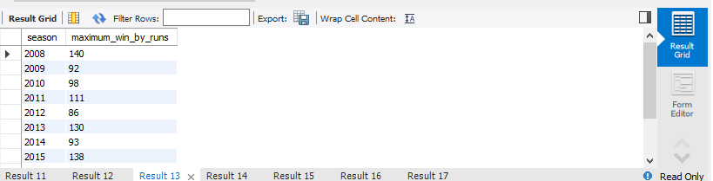

Q27. Find the maximum win_by_wickets recorded in each season.

SELECT season,
MAX(win_by_wickets) AS maximum_win_by_wickets
FROM matches
GROUP BY season
ORDER BY season;
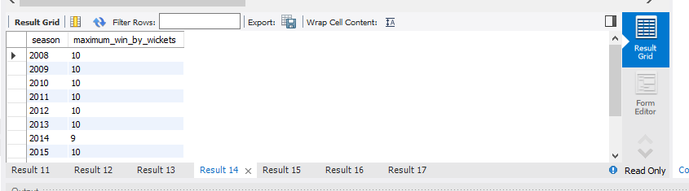

Q28. Count the total number of sixes (batsman_runs = 6).
SELECT COUNT(*) AS total_sixes
FROM deliveries
WHERE batsman_runs = 6;
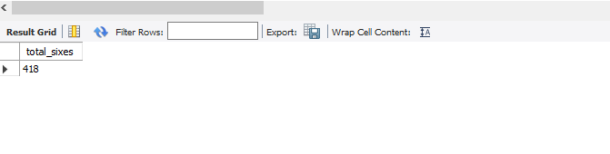

Q29. Count the total number of fours (batsman_runs = 4).
SELECT COUNT(*) AS total_fours
FROM deliveries
WHERE batsman_runs = 4;
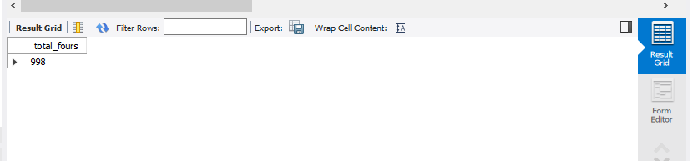

Q30. Find the total number of wide runs.
SELECT SUM(wide_runs) AS total_wide_runs
FROM deliveries;
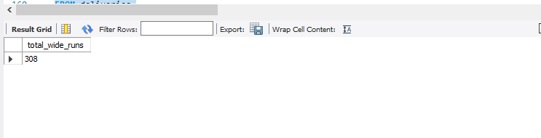

Q31. Find the total number of no-ball runs.
SELECT SUM(noball_runs) AS total_noball_runs
FROM deliveries;

Q32. Find total batsman runs scored by each batsman and show the top 10.
SELECT batsman,
SUM(batsman_runs) AS total_runs
FROM deliveries
GROUP BY batsman
ORDER BY total_runs DESC
LIMIT 10;

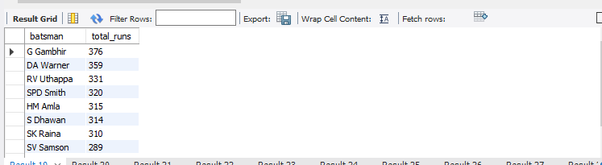

Q33. Find the number of sixes hit by each batsman and show the top 10.
SELECT batsman,
COUNT(*) AS total_sixes
FROM deliveries
WHERE batsman_runs = 6
GROUP BY batsman
ORDER BY total_sixes DESC
LIMIT 10;
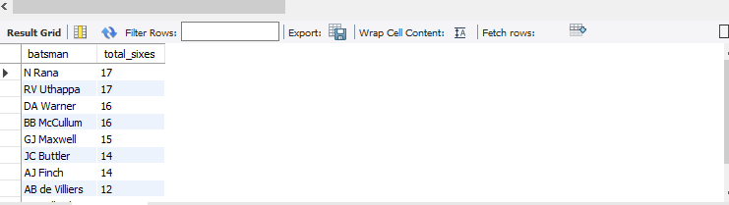

Q34. Find the number of fours hit by each batsman and show the top 10.
SELECT batsman,
COUNT(*) AS total_fours
FROM deliveries
WHERE batsman_runs = 4
GROUP BY batsman
ORDER BY total_fours DESC
LIMIT 10;
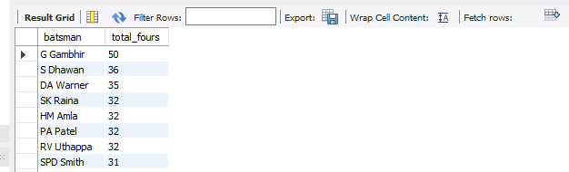

Q35. Find the total runs scored by each batting team.
SELECT batting_team,
SUM(total_runs) AS total_runs
FROM deliveries
GROUP BY batting_team
ORDER BY total_runs DESC;
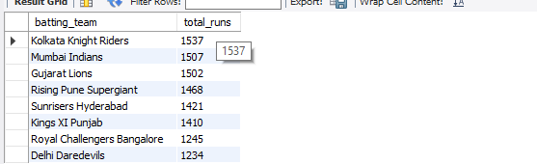

Q36. Find the total extra runs received by each batting team.
SELECT batting_team,
SUM(extra_runs) AS total_extra_runs
FROM deliveries
GROUP BY batting_team
ORDER BY total_extra_runs DESC;
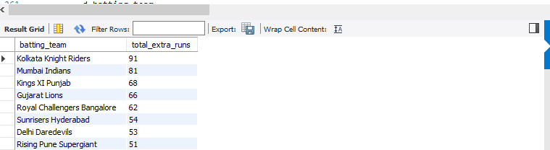

Q37. Count the number of deliveries bowled by each bowler and show the top 10.
SELECT bowler,
COUNT(*) AS total_deliveries
FROM deliveries
GROUP BY bowler
ORDER BY total_deliveries DESC
LIMIT 10;
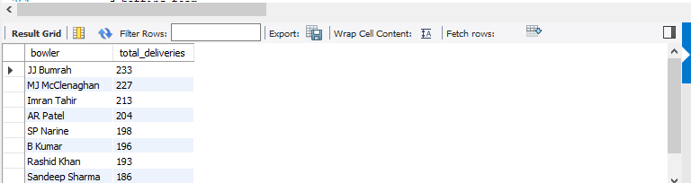

Q38. Find the total runs conceded by each bowler using total_runs and show the top 10.
SELECT bowler,
SUM(total_runs) AS total_runs_conceded
FROM deliveries
GROUP BY bowler
ORDER BY total_runs_conceded DESC
LIMIT 10;
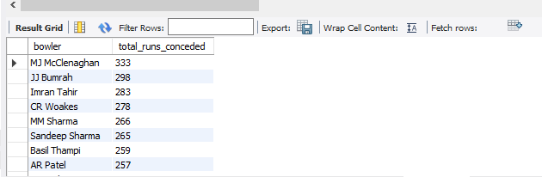

Q39. Count the number of recorded dismissals for each bowler, excluding run out, and show the top 10.
SELECT bowler,
COUNT(*) AS total_dismissals
FROM deliveries
WHERE player_dismissed IS NOT NULL
AND dismissal_kind <> 'run out'
GROUP BY bowler
ORDER BY total_dismissals DESC
LIMIT 10;

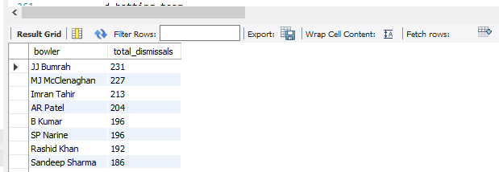
Q40. Count how many dismissals occurred for each dismissal_kind.
SELECT dismissal_kind,
COUNT(*) AS total_dismissals
FROM deliveries
WHERE dismissal_kind IS NOT NULL
GROUP BY dismissal_kind
ORDER BY total_dismissals DESC;
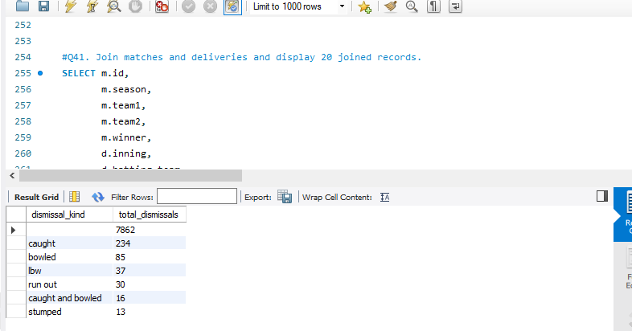

Q40. Count how many dismissals occurred for each dismissal_kind.
SELECT dismissal_kind,
COUNT(*) AS total_dismissals
FROM deliveries
WHERE dismissal_kind IS NOT NULL
GROUP BY dismissal_kind
ORDER BY total_dismissals DESC;
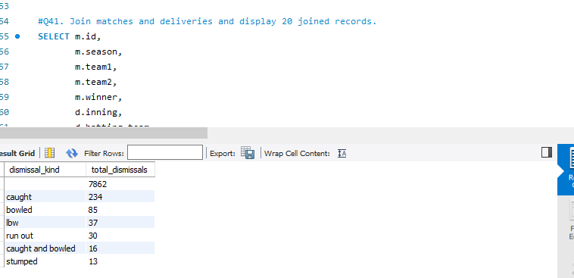

Q41. Join matches and deliveries and display 20 joined records.
SELECT m.id,
m.season,
m.team1,
m.team2,
m.winner,
d.inning,
d.batting_team,
d.bowling_team,
d.batsman,
d.bowler,
d.total_runs
FROM matches m
JOIN deliveries d
ON m.id = d.match_id
LIMIT 20;
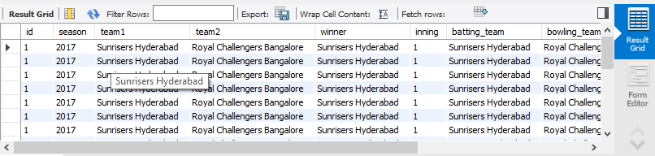

Q42. Using the joined tables, find the total runs scored in each IPL season.
SELECT m.season,
SUM(d.total_runs) AS total_runs
FROM matches m
JOIN deliveries d
ON m.id = d.match_id
GROUP BY m.season
ORDER BY m.season;
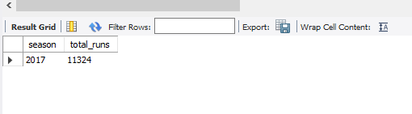

Q43. Using the joined tables, find the total number of sixes in each season.
SELECT m.season,
COUNT(*) AS total_sixes
FROM matches m
JOIN deliveries d
ON m.id = d.match_id
WHERE d.batsman_runs = 6
GROUP BY m.season
ORDER BY m.season;
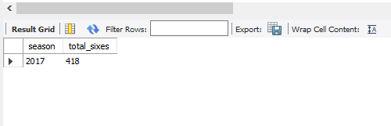

Q44. Using the joined tables, find the total number of fours in each season.
SELECT m.season,
COUNT(*) AS total_fours
FROM matches m
JOIN deliveries d
ON m.id = d.match_id
WHERE d.batsman_runs = 4
GROUP BY m.season
ORDER BY m.season;
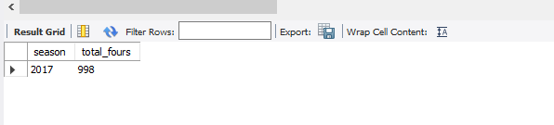

Q45. Using the joined tables, find the total extra runs in each season.
SELECT m.season,
SUM(d.extra_runs) AS total_extra_runs
FROM matches m
JOIN deliveries d
ON m.id = d.match_id
GROUP BY m.season
ORDER BY m.season;
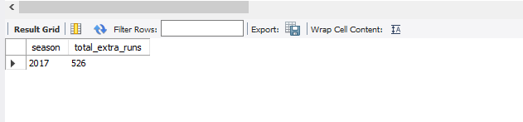

Q46. Using the joined tables, find total runs scored by each batting team in each season.
SELECT m.season,
d.batting_team,
SUM(d.total_runs) AS total_runs
FROM matches m
JOIN deliveries d
ON m.id = d.match_id
GROUP BY m.season, d.batting_team
ORDER BY m.season, total_runs DESC;
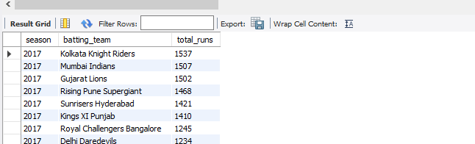

Q47. Using the joined tables, find the top 10 run scorers in the 2017 season.
SELECT d.batsman,
SUM(d.batsman_runs) AS total_runs
FROM matches m
JOIN deliveries d
ON m.id = d.match_id
WHERE m.season = 2017
GROUP BY d.batsman
ORDER BY total_runs DESC
LIMIT 10;
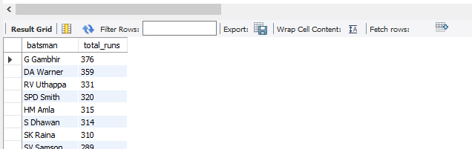

Q48. Using the joined tables, find the top 10 venues by total runs scored.
SELECT m.venue,
SUM(d.total_runs) AS total_runs
FROM matches m
JOIN deliveries d
ON m.id = d.match_id
GROUP BY m.venue
ORDER BY total_runs DESC
LIMIT 10;

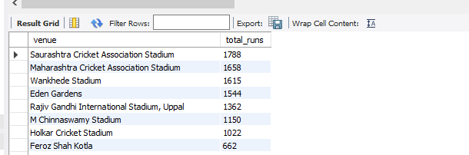

Q49. Using the joined tables, find the number of recorded dismissals in each season.
SELECT m.season,
COUNT(*) AS total_dismissals
FROM matches m
JOIN deliveries d
ON m.id = d.match_id
WHERE d.player_dismissed IS NOT NULL
GROUP BY m.season
ORDER BY m.season;
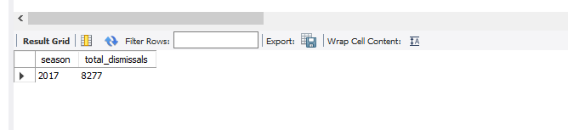

Q50. Show each match ID, season, winner, and total runs scored in that match, ordered from highest match total to lowest.
SELECT m.id AS match_id,
m.season,
m.winner,
SUM(d.total_runs) AS total_runs
FROM matches m
JOIN deliveries d
ON m.id = d.match_id
GROUP BY m.id, m.season, m.winner
ORDER BY total_runs DESC;
